**Prototype Testing**  
This document will contain the user testing process for the final prototype and in turn, the game overall, before evaluating the third prototype. This document will also consist of the modifications made from the data collected to make a finalised project.

**Testing – Method & Questionnaire**The testing process for this third prototype will be in the form of modern game quality assurance test. The participants, rather than be given a chunk of the project to look at, will be given the entire game to look at and play with. The intention of this is so the participants could note down any bugs or issues that they find while also commenting and assessing the game they just played. The questionnaire itself is split into two sections.  
The first section is a group of a small group of yes/no tick box questions; these are there to ask about the fundamentals of the game they are playing:

* Did the game load to the next scene?
* Did the player spawn into a square ‘hub’?
* Were you able to navigate to the end of the map?
* Did you clip through any of the walls in the map?
* Did the end take you back to the main menu?

The second section is a set of open worded questions, asking for more detail on specific parts of the game and requesting for comments on improvements and suggestions:

* What do you think of the player controls? Any changes you would make?
* What do you think of the generated map? Any changes you would make?
* What do you think of the theme and visuals of the game? What would you make different or what would you add?
* Any other comments on the game?

**Testing – Results & Feedback**The results and feedback for the test was moderately positive. None of the participants had and issue with the game itself; all participants were able to easily start, play and finish the game with multiple map generations – navigating through the procedurally generated map was not a problem. Modifications made after the testing process of prototype two were also well received, with the sensitivity and sprint options as main highlights. There were a few concerns that were universal to everyone who participated in the test:

Polish and Tweaking  
The majority of the negative comments made during the testing process of this prototype was that there wasn’t enough polish when playing the game. Some buttons weren’t properly scaled with the visual text that made up the buttons, the camera in some places was able to clip through some places and overall they felt that there was a feeling of the prototype being rushed.

Theming  
The main reason I selected the simplistic and minimal cubic theme was to cut down on complexity and cut down on development; while it did considerably cut down on the development process, the theme itself was not well received. I have gained a lot of recommendations to change the game to horror-like or adding some form of horror aspect to it such as navigating in darkness.

Closed Off Bug – 1% Chance  
Before the main testing started, a participant of the focus group was using the current prototype and unfortunately came across a game breaking bug – the entrance pathway from the starting spawn of the map was created too narrow, this prevented the participant from progressing through the game and ultimately forcing him to quit the game. This bug has only been found once throughout the entirety of testing and it is unsure whether it will ever be found again due to the nature of procedural generation.

**Development Feedback & Responses**

Polish and Tweaking  
Compiling the information gathered from the testing process as well as noting down issues I found via multiple playthroughs of the prototype, I have performed a few changes and tweaks to fix a lot of the smaller problems found within the prototype:

* Build Map Button Bug: The trigger box for the button to generate the map was smaller than what it was scaled up to – this has been resolved and now moving the cursor over the text will activate the trigger as intended.
* Increased Pathway Size: In order to prevent the closed pathway bug from happening, the draw circle function now draws circles with a radius of 4 instead of 3. This will widen the pathways enough for the problem to be removed but is only a slight increase, not completely opening the generated map.
* Border Walls: The physical mesh of the map is hollow, building only the walls get generated. This and the combination of the camera allowed you to see through the mesh in the far side of the cone of vision if in contact with a wall – exposing the player to the default Unity skybox. I have included a thin border surrounding the main plane to close off the skybox.

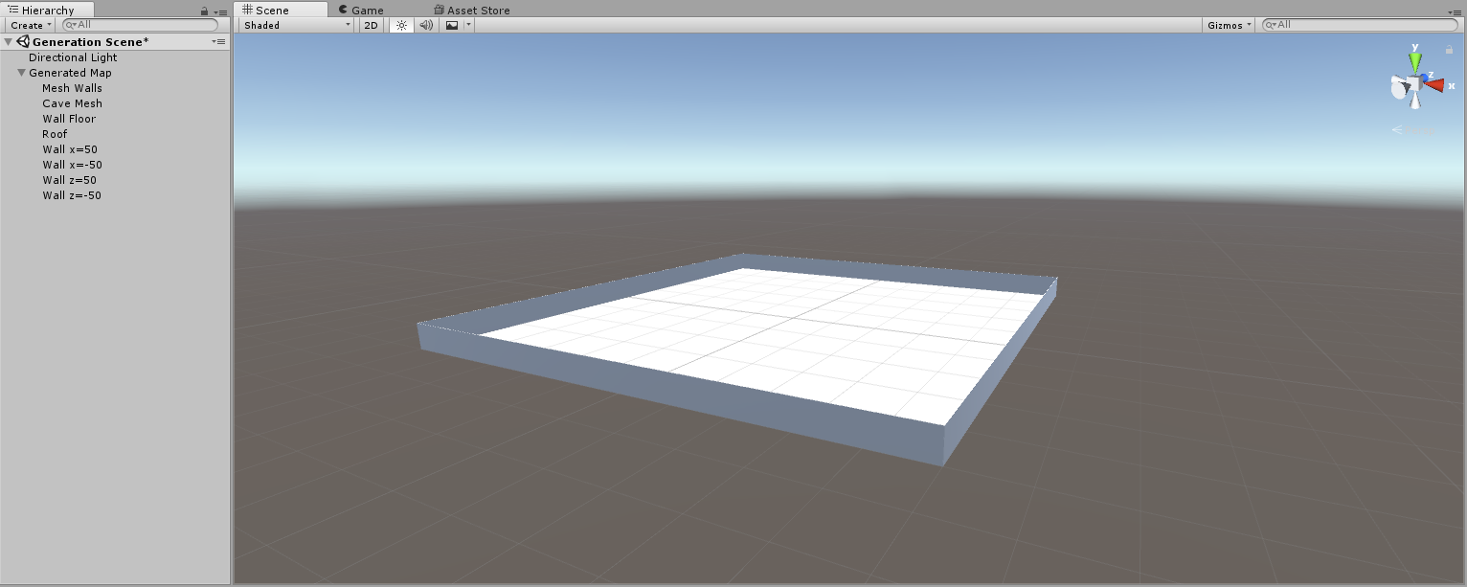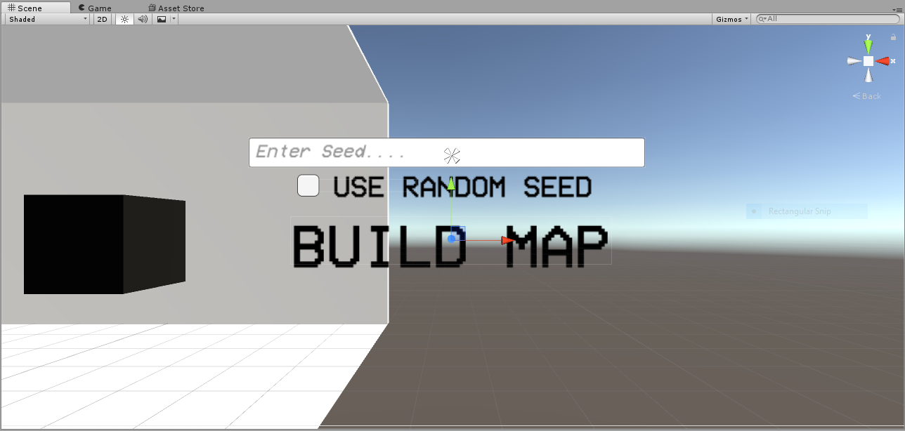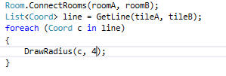

Theming  
Personally, I feel that keeping the theme barebones was beneficial for the development process of my game in the sense of time and management of the most important parts of the project. I have decided to hold theming development of the game as I was still working of mechanical tweaks and fundamental development.

**Prototype Evaluation**This prototype consisted of fixing a lot of loose ends, which isn’t bad in itself but the negative points coming from that fact that the development from previous prototypes suffered from lack of more focused bug-checking and fixes. With this more focused look on edits and tweaks, I feel like I have built a more complete prototype and in turn a more complete game.